INVITATION TO PUBLIC LECTURE
Staff and Students
FACULTY OF AGRICULTURE
TOPIC: Research Advances in Grasslands for Improved Productivity in the Tropics: Breeding Opportunities for Food Security and Climate Resilience!
BY Dr. DoKyoung Lee
DATE: 4TH DECEMBER 2024
Time: 2-4pm
VENUE: FACULTY OF AGRICULTURE 844 HALL

Biodata
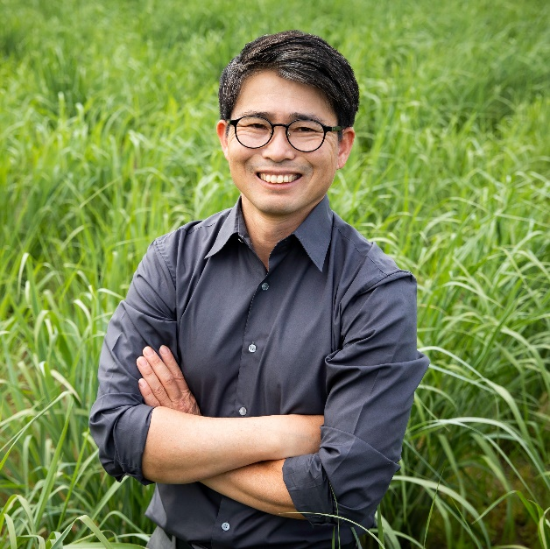
Dr. DoKyoung Lee is a distinguished professor of crop sciences at the University of Illinois Urbana-Champaign and recipient of the Jack and Majorie Professorship of Plant Breeding and Genetics. Dr. Lee is the director of the Sustainable Agriculture Lab, drawing on his extensive background in soil science, crop production, perennial grasses, and international agriculture to enhance native perennial grass systems for sustainable biomass and bioenergy feedstock production while maximizing ecosystem services. His research is largely dedicated to optimizing perennial grass crops by increasing their productivity, improving their abiotic stress tolerance, and developing best agronomic practices. In addition to his work with perennial grasses, Dr. Lee also leads the flagship hemp and cannabis breeding program at the University of Illinois Urbana-Champaign. This program focuses on genetic improvement and agronomic management of hemp and cannabis for flower, fiber, and seed production, further extending its impact on sustainable cropping systems.
His current work emphasizes the environmental benefits of integrating native perennial species into row cropping systems, such as carbon sequestration, water quality improvement, and enhanced biodiversity, contributing to the broader goals of low-carbon-intensity agricultural practices.
Dr. Lee earned a bachelor's degree in agricultural chemistry and a master’s degree in agro-environmental chemistry and environmental soil physics, both from Chungnam National University, Taejon, Korea. Dr. Lee holds a Ph.D. in Agronomy and Environmental Soil Science from South Dakota State University. Dr. Lee has coordinated several national and regional agricultural extension programs and led US Department of Energy research initiatives on perennial grasses. His career has been impactful for the growing bioeconomy, and invaluable for the discipline of sustainable agriculture.

