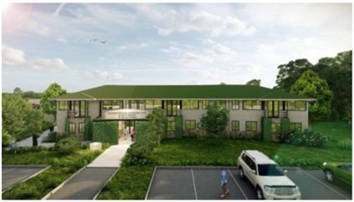
AGRICULTURAL TECHNOLOGY AND INNOVATION CENTRE (ATIC)
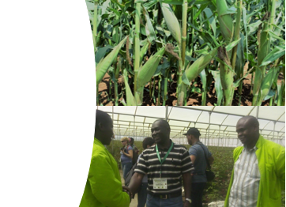
University
&
Industry
Led
Outreach
Vision
To be a Centre of Excellence for Innovation, Practical Training, Incubation and Commercialization of Market-Demanded Products and Services
Mission
To nurture a robust agricultural innovation ecosystem through synergistic action and exchange of knowledge among diverse actors to deliver globally competitive agribusiness, resilient livelihoods, and environmental sustainability
ATIC Hub at UoN-Upper Kabete Campus

Conceptual Framework of ATIC
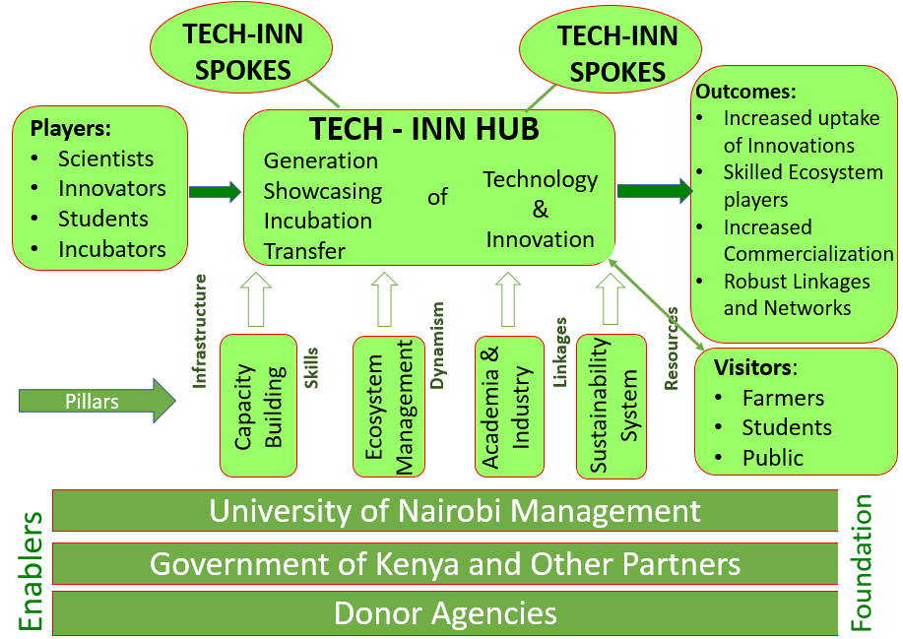
Model of ATIC: hub and spokes
- The ATIC hub will be based at the UoN-Upper Kabete Campus

- The hub will be replete with demonstration plots, exhibition facilities and social amenities.

- The spokes will be agricultural technology units in other public and private organizations.

The scope and pillars of ATIC
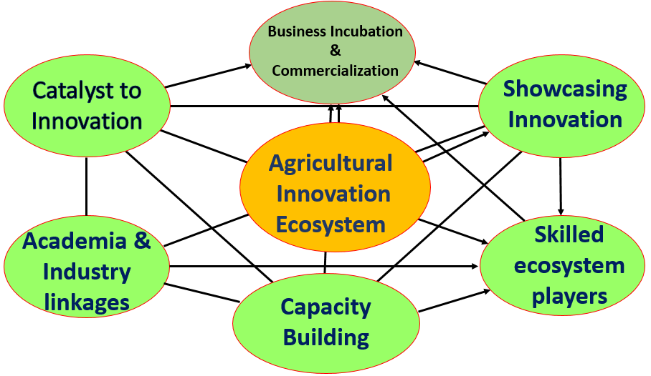

Contacts
Agricultural Technology and Innovation Centre (ATIC)
University of Nairobi
Upper Kabete Campus
P. O. Box 29053– 00625
KANGEMI
Email: pr@uonbi.ac.ke

Statement of the Problem
- Evolving challenges, against inadequate investment in development of agricultural technologies and innovations
- Weak extension services contributes to low uptake of technology especially by smallholder farmers.
- Needs of farmers and the industry are not adequately articulated and communicated to the scientific community.
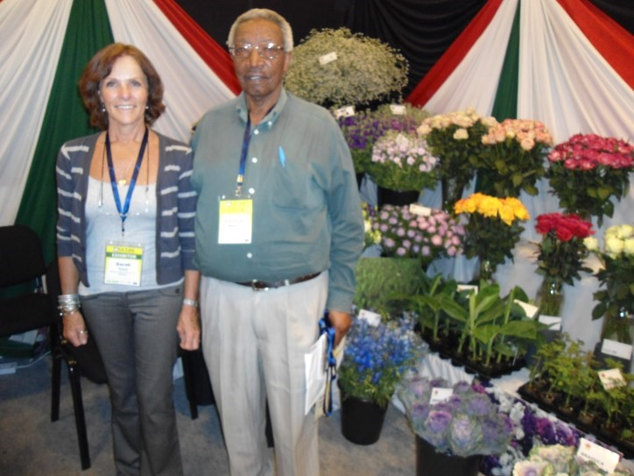
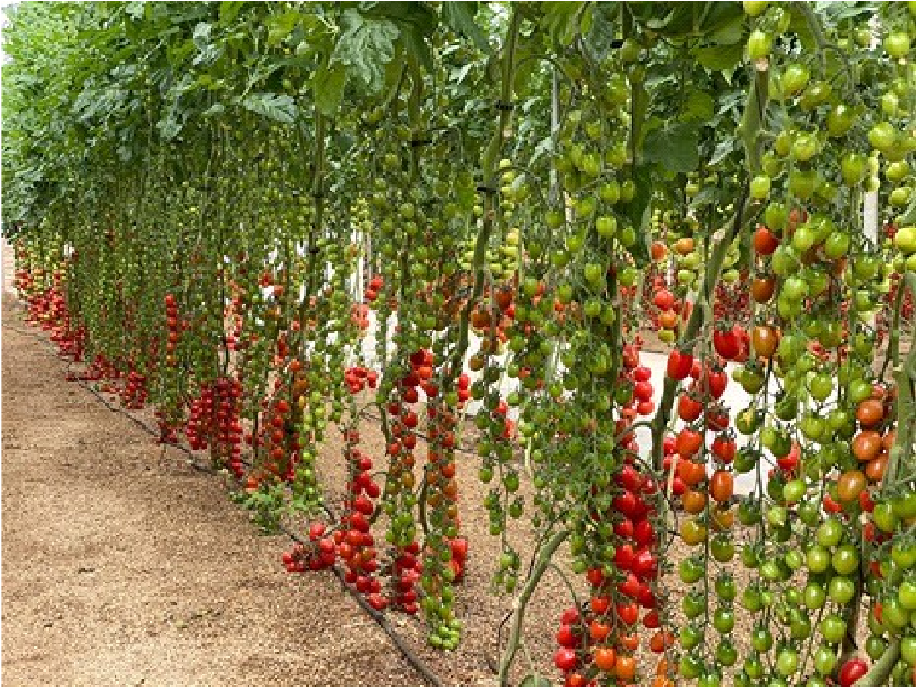
- Low employability of graduates due to mismatch between knowledge, skills and competencies acquired and what the market needs.
Justification
- African higher educationiInstitutions (HEI) have been advised to champion innovatiion initiatives as a catalyst for the economies to transform into sustainable systems that provide opportunities for all.
- This initiative will strengthen the innovatiion capacity of university communities, SMEs, start-ups, and the entire industry.
- Joint action will generate innovative products as well market-demanded curricula, and market-ready graduates with appropriate and comprehensive skill sets.
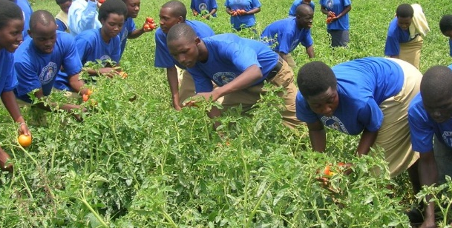
- Multiple dividends from sharing of resources, synergy and networking will accrued.
Demonstration plots
Demonstration plots

Expected outputs
- A hub for development and showcasing of agricultural innovations and technology transfer established and commissioned.
- Database of expertise, products, innovations, and services established
- Demonstration plots and exhibition space developed and equipped.
- Strategies of incubation and commercialization of promising innovations developed and operationalized.
- Outreach and extension programme developed and operationalized in partnership with the industry.
- Curricula for short-term and tailor-made training courses, on innovations, for specific target groups developed.
- Strategy for industrial internship and student exchange developed and operationalized.
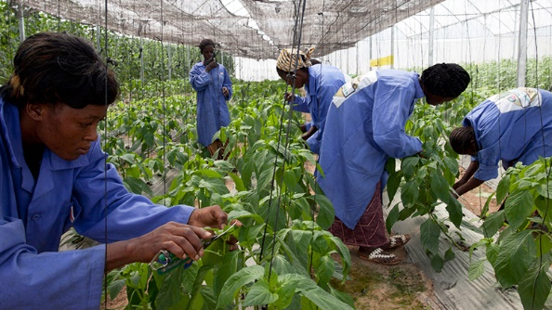
- Seamless access to technical assistance and expertise by farmers and other stakeholders established.
Experiential learning

